Best practices for Differentiated Learning, Experiential Learning, a Global Perspective

Engaging students in the social sciences of Family Studies can be accomplished in a number of best practices. The most important are to provide a learning environment based on differentiated learning, experiential learning and ensuring that the teaching provides a global perspective. Teaching from a global perspective is one of the most important practices as it opens the young mind to a social and self aware state. The other key practice to incorporate in programming is differentiated experiential learning. This practice is key in Family Studies social science as the most ingrained learning comes from doing and participating. This practice leads to providing differentiated instruction and planning for exceptional students that make the Family Studies courses more appealing to students.
The practical hands on aspects of the courses appeal to students and provide the foundation for experiential learning in many of the family Studies courses. For example, nutrition education is a subject area that every student will have the opportunity to draw on throughout his or her lives. The experiences that help form their knowledge in this subject will have a profound affect on them how they take care of themselves and others in the future. Positive practical experiences that influence nutrition knowledge are the type of experiences Dewey believes will live fruitful and creatively in subsequent understanding (Dewey,1938). A quote from Confucius sums up the importance of experiential learning; tell me, and I will forget; show me, and I may remember; involve me, and I will understand. Delivering knowledge that does not connect the student to the material is an effort wasted on both the educator and the learner. Teaching approaches used for students in their teens must be considered from an approach that will promote the most connection to the student. Many ideas listed on the LKDSB web site for differentiated learning work well with experiential learning. LKDSB emphasizes that differentiated instruction is effective instruction that is responsive to the learning preferences, interests and readiness of the individual learner. Experiential learning as a best practice for many of the hands on Family Studies courses is essential in building differentiated instructional strategies.
Best practices should have a socially positive outcome in addition to the benefits they are destined to provide to students. Therefore, global education is important in identifying issues central to all student’s lives and providing students with awareness of life outside their country. It lays the foundation for understanding the issue of global obesity while providing with practical food preparation skills through hands on learning. The experiential learning occurring in this teaching this perspective will provide students with a connection to the material that will enable them to make directly compare events in around the globe to their own lives. As participants in and citizens of the world, we have an obligation to address the problems that face humanity. These issues are part of students’ reality, so school should address them in order to equip students to effectively deal with them—as well as similar and related issues and problems that may arise in the future (McLeod,13). For example, food is an important component of everyone’s daily routine, and the choices we make daily affect us throughout our lives. An understanding of the affect food consumption choices have on the body is the first step in educating youth about the consequences of poor food choices. Provoking thought, discussion and creating practical hands on learning experiences will connect these issues directly to the students’ lives. Global education navigates the tension between honoring the student as an individual and taking into account the entire world in which the individual finds herself or himself (McLeod,14). Teaching practices should benefit the student in a manner that promotes personal growth as well as academic.
I feel that promoting a global perspective, in addition to differentiated instruction and experiential learning are the most important practices a Family Studies teacher can incorporate into teaching methods. These perspectives can become ingrained in teaching methodology and provide students with transferable skills as well as an international social perspective that will be required in our current global world.
The following lesson provide examples of DI that can be incorporated in both the Foods and Fashion courses of the Family Studies Curriculum. These resources are intended for teachers to use an adapt as needed, ultimately making them their own.

McLeod, C. (2008, Spring). Global education: an example of transformative pedagogy. Social Justice Newsletter, British Columbia Teachers’ Federation, 13-14. Retrieved from http://bctf.ca/ uploadedFiles/Public/SocialJustice/ PublicationsSJ-Newsletter/Spring2008.pdf

Lambton Kent District School Board. (2007b). Differentiated instruction videos. Retrieved on August 20, 2008 from http://www.lkdsb.net/program/elementary/
intermediate/di/index.html

Food Insecurity in the World - Differentiated Instruction
Subject: Family Studies HFA4M

Grade: 12 open
Ontario Standards:
- Identify, select, and effectively use appropriate kitchen tools to plan and prepare interesting and appealing meals in cooperation with others.

- Identify the various reasons for the choices people make about food

- Demonstrate appropriate use of social science research methods in the investigation of food related issues.
- Describe social, economic, and environmental impacts of global nutrition
- Describe the local, provincial, national, and global impacts of food distribution

Anticipatory Set: Provide all students with a small sample of packaged dried meat to taste.
Specific Objectives:
- Create awareness of the types of food that families in other countries are eating.
- Students will make connections between the discrepancies of global food availability
- Encourage students to sample a very small portion of dried meat and Aiysh (Congealed Porridge)
Required Materials:
- Dried meat – beef or pork purchased from market
- Millet flour
- Aiysh Recipe
- Class copies of article – The state of food insecurity in the world – by the Food and Agriculture Organization of the United Nations
- Overhead map of Dietary Energy Supply
- 10 copies of Hungry Planet by Peter Menzel and Faith D”Aluisio or
- Projector with access to the online site; http://www.google.ca/search?q=what+the+world+eats&hl=en&client=safari&rls=en&prmd=imvnsb&tbm=isch&tbo=u&source=univ&sa=X&ei=wQEDUJe1E4LJ6wG8j7jGBg&ved=0CF4QsAQ&biw=1287&bih=632

Step-By-Step Procedures: (75 minute period)
- Prior Knowledge: The day before introducing a new topic or unit, assign the following task: Each student must find out one fact about the required topic. They must also record their source (parent, TV, book, magazine, website, author if possible, etc.) “Find out one recent fact about “World Hunger”.
- At the beginning of the very next class, students record their individual facts as well as their sources on the chart paper provided. The papers are then posted for a few days. It is amazing how much information this communal effort produces.
- Handing out dried meat sample. (2 min.)
- Ask for student reactions to the taste and texture, comparisons to other foods they have eaten, personal opinions. (2 min.)
- Differentiated Instruction Activity - Great activity for students to gather their thoughts about any topic, or to come up with “key issues”. A piece of chart paper is divided into sections based on the number of members in the group, with a square or a circle in the middle.The circle in the middle denotes the continent and each section lists a different country.(This can be used with groups of 2 to 7 – depending on students’ experience with group work)
- Investigation of Food Insecurity. You want to know what the students already know. You ask them to write down individually what they know about the food people eat in any of their countries in their continent.t. Each student writes this down in his or her space. Groups can present to the class what they know about global foods.
- Put map Dietary Energy Supply on overhead. Ask students to look over the map individually and jot down at least two observations on a piece of paper. Have students share observations to promote discussion. (10 minutes)
Students will likely comment on:
- U.S and Europe consume the most calories
- A significant portion of Africa consumes the least calories
- Divide students into 6 or 7 groups and assign each group of students a portion of the article: The state of food insecurity in the world – by the Food and Agriculture Organization of the United Nations. Students must read their portion (5 min.) and write the important facts on chart paper to share with the rest of the class. (10-15 minutes)
- Show overhead picture of Refuge family in Chad, outside Dafur. Presentation on this family’s life in the Breidjing Refuge Camp. (15 minutes)
- Demonstrate the method for making Aiysh and encourage students to sample. (10 minutes)
- Explain that the presentation just given was a demonstration of the final unit project.
- Assign unit project. Hand out group assignment details and rubric for the unit assessment. Give students 5-10 minutes to choose the country they wish to research and look over chapter in the Hungry Planet. Record selections.(5-10 minutes)

Closure (Reflect Anticipatory Set):
- Ask each group the reason for their selection. They should be able to tie it into the discussions of earlier
- Let students know that the following day will be a work period to prepare the outline for the presentation, begin research, and find two additional sources for information.
Evaluation:
- Formative
  - All students speak at least once during class discussions.
  - Most students taste the two new foods offered.
Reflective Statement:
Other:

What the World Eats – Group Presentation Assignment

- Students will prepare an oral presentation AND a poster board, or a power point, or a prezi, that describes your country’s food choices.

- Required information

  - Map - City/Country/Continent (3 marks)
  - Population Density and explanation of how it affects the country (5 marks)
  - Meat consumption per person (1 mark)
  - Cigarette or fast food consumption per person (1 mark)
  - Life expectancy (1 mark)
  - Caloric intake per person (1 mark)
  - Overweight/ Obesity population (1 mark)
  - Description of daily life and eating habits of a typical family (8 marks)
  - Pictures of people and food (4 marks)

- Each group member describes at least one aspect of the poster board. (3 marks)

- Presentation will take place on the last two days of the unit.

- Must use two or more additional sources in addition to Hungry Planet. (2 marks)

- Prepare one dish from your chosen country. (10 marks)

- Group participation, co-operation, attitude (10 marks)

GROUP PROJECT OBJECTIVE SHEET - Group Members___________________,

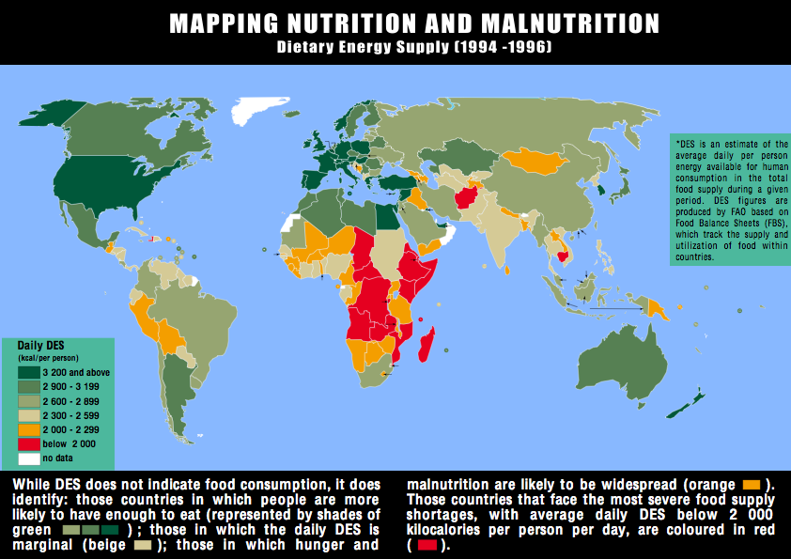
_________________, ___________________, __________________, _______________

- Two outside sources of information
____________________________________

____________________________________

2. RECIPE ______________________________

3. INGREDIENT LIST
Item______________________ Quantity_____________________
Item______________________ Quantity_____________________
Item______________________ Quantity_____________________
Item______________________ Quantity_____________________
Item______________________ Quantity_____________________
Item______________________ Quantity_____________________
Item______________________ Quantity_____________________

CALORIC INTAKE – Intake availability per person per day

Australia – 3,054
Bosnia - 2,894
Canada - 3,482
Chad - 2,114
China - 2,951
Cuba – 3,152
Ecuador - 2,754
Egypt - 3,338
Ethiopia - 1,667
France - 3,654
Germany – 3,496
England - 3,412
Guatemala - 2,219
India – 2,459
Italy – 3,691
Japan - 2,761
Mali - 2,174
Mexico - 3,145
Mongolia - 2,249
Somalia - 1,906
U.S. - 3,774

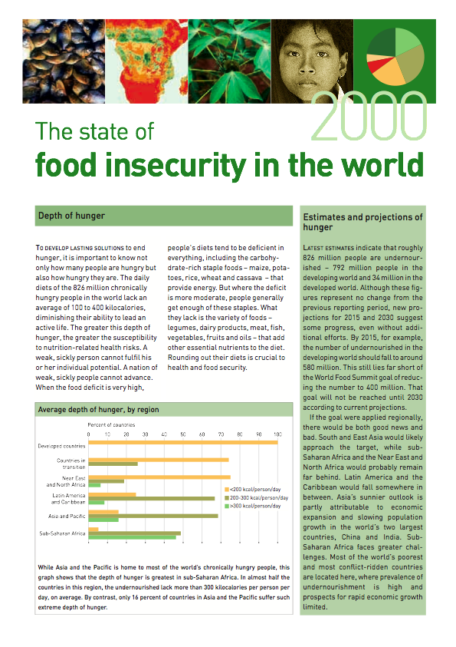

UNIT OVERVIEW
Unit #1: Investigation of Food Choices
Time: 19 Hours

Description:

In this unit, students will develop an understanding of social science research methods which will be applied in each of the following units. Students will be able to identify the reasons why people make the food choices they do and explain a variety of influences on individual food choices. Students will apply social science research methods to an investigation of current food marketing techniques and an illustration of career opportunities related to food and nutrition.

Strand(s): Self and Others; Personal and Social Responsibilities; Social Science Skills
Overall Expectations: SOV.02X, PRV.02X, SSV.01X, 02X
Specific Expectations: SO2.01X, 02X, 03X, PR2.03X, SS1.02X, 03X, 04X, 05X, SS2.01X,
02X, 03X, SS3.01X, 02X

From: Course Profile - Food and Nutrition http://curriculum.org/profiles/grade-12-public-social

Lesson Plan
Subject: Food and Nutrition 9/10 HFN10/20
Title: Obesity and the Culture of Fast Food – Your favourites
Ontario Standards:
- Identify the various reasons for the choices people make about food
- Explain how families, peers, and the media influence an individual’s food choices and habits.
- Analyze the responsibilities involved in maintaining nutritional health and well-being
- Identify consumer responsibility in the investigation of current food issues
- Use research derived from a variety of primary sources (e.g., interviews, observations, statistics, demographic research, and original documents) and secondary sources (e.g., print materials, Internet articles, CD-ROMs, and videos
- Distinguish between research evidence and opinion
- Evaluate print and electronic resources on food and nutrition for validity, reliability, accuracy, bias, and relevance.

Prior Knowledge: Previous lessons concentrated on How the Media Influences What We Eat, Food Styling, Food Styling Challenge, Super Size Me
- Homework assignment from previous class was to choose their favorite fast food and try to source the nutritional information for the meal.

Anticipatory Set: Collect students’ homework as they walk in the door. Let them know that this information will be used later in the class. (The class will be divided later into groups, determined by the types of foods they chose.)

Specific Objectives
- Investigate a variety of fast food favourites and make comparisons to healthy substitutes.
- Students will make comparisons between fast foods at various restaurants
- Students will research their own recipe for a healthy alternative

Required Materials:
- Computer / Projector
- Recipes / Cookbooks
- http://www.livestrong.com
- http://www.eatracker.ca/
- http://nutritiondata.com/
- Obesity Article – class set
- Book Computer Lab
- Rubric attached
- Assignment attached

Step-By-Step Procedures: (75 minute period)
  - Briefly, summarize the previous days activities and lead into a discussion about the assignment they had to finish for homework. Allow students to share their choice of fast food alternative. What were the findings? Where they surprised by the results of their choices? Why? (15 minutes)
  - Show the nutrition data slides for various fast foods, ppt. attached. Explain the how to read the detailed information. Go through a number of slides and ask students to explain the images. Check for understanding by having as many students as possible answer questions. (10 minutes)
    - How many calories in this food item?
    - How many calories from fat? What does that mean?
    - What is the sodium level?
    - How much sodium does a person need?
    - What vitamins or minerals does this food provide?
  - Hand out article on Obesity and Fast Food. Have students read independently (or aloud). Discuss the key points made in the article. Refer to highlighted sections of the article during discussion. (10 minutes)
  - Using the Four Corners DI Method pose the question ‘ Does Fast Food Cause Obesity ?’. Four Corners. Post up on the wall in each corner a sign that says Strongly Agree, Agree, Disagree and Strongly, Disagree. Read the students a statement and they walk to the corner that best describes their feeling on the topic. After they have chosen their corner, they have a few minutes to discuss amongst themselves their feelings on the topic, and then a spokesperson from each group tells the class the group consensus.
  - Show students how to use the websites, http://www.livestrong.com http://www.eatracker.ca/ to source the nutritional data for various fast food choices. Ask for examples of foods they would like to look up.
  - Group Activity – Divide students into groups according to the food they researched for homework. Write the task on the board. Students must decide on one item from their fast food list to transform into a healthy alternative. Students are to look through the recipes available in the classroom, find an alternative, research the nutritional information, support their decision in a written paragraph or statement, and produce a list of ingredients required. The remainder of the class is given to planning time.
  - Circulate during group work to keep students on task and monitor progress of activity.
  - Computer lab Planning: Students have the opportunity to research their fast food choice and the healthy alternative in order to complete their assignment. Students use eatracker or livestrong to complete activity.
Formative Assessment
  - All students speak at least once during class discussions
  - Check for understanding – Group supports their food choice by using information covered in classes during this unit.
- Summative: to follow see attached rubric for final task
  - Supportive statement should include at least 3 reasons why their food choice in a healthy alternative to the comparable fast food item.
- Reflective Statement:
- Other:

MAKE IT HEALTHY - POSTER BOARD PRESENTATION

CHOOSE ONE FAST FOOD MEAL AND TRANSFORM IT INTO A HEALTHY ALTERNATIVE. A MEAL SHOULD INCLUDE FOODS THAT ARE NECESSARY IN A BALANCED DIET. ( Main, side, beverage)

1. RESEARCH AND PRESENT THE NUTRITIONAL INFORMATION FOR THE FAST FOOD MEAL YOU HAVE CHOSEN TO REPLACE. (5 Marks)

- PROVIDE A WRITTEN DESCRIPTION OF THE HEALTHY MEAL ITEMS FOR MARKETING PURPOSES. What factors would you focus on to sell this meal? (5 Marks)

- PROVIDE RECIPES FOR EACH FOOD ITEM IN THE HEALTHY MEAL. BE SURE TO INCLUDE RECIPE REFERENCES. (5 Marks)

- PROVIDE NUTRITIONAL INFORMATION FOR YOUR MEAL. (5 Marks)

- WRITE A SUPPORTIVE STATEMENT (about one paragraph) FOR YOUR MEAL.

- WHAT IS YOUR RATIONALE FOR CHOOSING THIS MEAL.
- DESCRIBE HOW IT IS A HEALTHIER ALTERNATIVE THAN ITS FAST FOOD COUNTERPART.
- WHAT IS THE MOST SIGNIFICANT HEALTH ADVANTAGE TO YOUR MEAL? WHY?

- PRESENT YOUR FINDINGS ON A POSTER BOARD

MAKE YOU FOOD CHOICES AS SOON AS POSSIBLE. NO DUPLICATES IN THE CLASS. SEE ME TO CONFIRM YOUR CHOICE

Does Fast Food Cause Obesity?
It seems like fast food is almost a daily topic in the news. Whether it is because of their ingredients (such as trans fat), the negative health effects (like diabetes), or being linked to obesity, fast food dominates the headlines. This then begs the question, "Does fast food cause obesity?" The simple answer is no. Consuming more calories from food than the body can burn is what causes weight gain. While environmental factors, such as regularly eating fast food, may increase the risk of obesity, they are not a cause of obesity (see Causes of Obesity or Causes of Childhood Obesity). In other words, they are risk factors.

This means that you could eat fast food on a regular basis and not become obese. In fact, you can even lose weight while eating fast food. This, however, requires knowledge of not only how many calories you are burning on a daily basis, but also the calories in the food that you are eating.

Fast Food and Obesity: The Research
Fast food is not the cause of obesity in today's society. However, because fast food is typically high in calories and the portions are large, it does promote eating too many calories, which can lead to weight gain and obesity.

Research has shown that people who eat fast food consume more calories than people who do not eat fast food. Those who eat fast food also consume more fat, saturated fat, and sodium (salt), while consuming fewer fruits, vegetables, and milk.

Research has also shown that fast food from major chains still has unacceptable levels of trans fat. Trans fats have a significant effect on the body and may contribute to weight gain, abdominal obesity, type 2 diabetes, and heart disease.

Finally, when compared to 10 years ago, portion sizes continue to be the same or larger at the major fast food chains.

Final Thoughts on the Impact of Fast Food on Obesity
Fast food is a reality in today's society, and the number of overweight and obese people continues to increase. Therefore, it might be easy to place blame on fast food as a cause for obesity. However, it is not that simple. There are many factors that increase the chances for obesity.

People who are concerned about the effects of fast food and obesity can also do something about it. There are many healthy fast food choices available. Fast food companies also do a good job of making nutritional information available, which can help a person make choices about what and where they eat.

Retrieved from:http://weight-loss.emedtv.com/obesity/fast-food-and-obesity-p2.html

 | Level 4  Exceeds Expectations | Level 3  Meets Expectations | Level 2  Meets Most Expectations | Level 1  Does Not Meet Expectations
Fast Food Analysis - thinking and inquiry | The fast food selected is a full meal. The nutritional information provides in depth detail of the food facts. Additional interesting details are added. | The fast food selected is a full meal. The nutritional information is complete. | Some parts of the fast food meal are incomplete. The nutritional information does not provide sufficient detail. | The fast food meal is incomplete. The nutritional information is not clearly provided
Healthy Meal Alternative  Knowledge and Understanding | The healthy meal meets all the food groups and the marketing description will definitely intrigue consumers. All nutritional information is provided clearly and in great detail/ | The healthy meal meets all the food groups and the marketing description is clearly written. All nutritional information | The healthy meal meets some of the food groups and the marketing description is provided. Details are missing. Most of the nutritional information | The healthy meal does not meet f the food groups and the marketing description is not provided. Details are missing. Most of the nutritional information is incomplete.
Recipes  Application | Recipes are detailed and easy to follow. The recipe provides all the steps necessary to produce the food items. References are provided for recipes where required. Additional information is provided to enhance method. | Recipes are detailed and easy to follow. The recipe provides the steps necessary to produce the food items. References are provided for recipes where required. | Recipes are listed but details are not provided and the method is unclear. The recipe does not provides the steps necessary to produce the food items. References are not complete. | Recipes are not provided and the methods are unclear. The recipe does not provides the steps necessary to produce the food items or the recipes are non-existent. References are not complete
Supportive Paragraph  knowledge and Understanding | The paragraph is detailed and provides more information than required. | The paragraph answers all the criteria listed on the assignment sheet. | Most of the criteria is provided, however there are gaps and incomplete information. | The paragraph is incomplete or non existent and does not reflect the criteria required.
Poster Presentation  Communication | Attention to detail is excellent. Time and effort is evident in the presentation of the information. | All criteria is covered and presented clearly in an attractive manner | Most of the information is presented. Details are lacking. | Large gaps in information are evident. expectations are not met in many categories.

DIFFERENTIATED INSTRUCTION FOR FASHION

Overall expectations : HNC30
- correctly use terminology associated with fashion, clothing, and textiles;

DI Idea - Terminology Bingo - sample lesson attached

Specific Expectations: HNC30

Dressing for Function and Occasion
By the end of this course, students will:
– describe the dress code that would be appropriate for a variety of jobs (e.g.,
office manager, store clerk, factory worker, receptionist, child-care worker) and special
occasions (e.g., graduation,wedding, funeral, job interview);
– compare features of the clothing worn by members of particular professions or occupations (e.g., police officer, doctor) in two or three different societies

DI Idea - List four or five social events on chart paper - students move around the class and write clothing selection ideas on each chart

Design, Technology, and Creative Expression
- create a variety of fashion products, using two or more technologies appropriately.

DI Idea - Practical culminating activities should provide a number of sewing options for students, provide 3-4 choices for students to choose from, ie. pj bottoms, drawstring bag, empire tube top, beach cover up,

– demonstrate an understanding of concepts and terms related to the elements of fabric
and fashion design (e.g., colour, types of lines, form, texture ) and the principles of design (e.g., harmony, rhythm, emphasis, proportion, balance );

DI Idea - Using homemade primary colour play dough or frosting for wafer cookies, allow students to experiment with mixing of colours. Teach the leason on colour and instruct students to prepare specific colour samples for categories determined by teacher - Detailed lesson attached

Function of Clothing Specific Expectations -
– explain the role that clothing has played in defining different classes or roles within a
society, drawing on examples from particular periods of history (e.g., the clothing of nobles,warriors, scholars, clerics, and artisans in the Middle Ages);

DI Idea - Create a power point or prezi - using ppt. template students create a ppt. for a given fashion time period - sample lesson attached

References;

History of fashion - http://www.uen.org/Lessonplan/preview.cgi?LPi

Colour wheel - http://www.uen.org/Lessonplan/preview.cgi?LPid=13207

Utah Education Network -http://www.uen.org/Lessonplan/LPview.cgi?grade=12

SEWING EQUIPMENT LESSON PLAN
Summary:
This lesson on sewing equipment should act as a review on information already covered. If students have questions as the game is played, this would be a great time to answer them and make sure that they have the correct information.
Main Curriculum Tie:
Clothing and Textiles I
Standard 1 Objective 1
Identify sewing machine parts and their function, safety, and maintenance.
Materials:
For this lesson you will need:
The sewing equipment terms printed off and copied onto an overhead transparency
An example of each of the items on the equipment list
A sewing machine and a serger (these are all necessary). The teacher will show the items to the students so they can then cross them off their bingo cards.
Students will need a blank sheet of paper and a pen or pencil.
Rewards for students that get bingos (optional)

Attachments
Equipment_Bingo_word_list.doc
Equipment_Bingo_word_list_1_.pdf

Background For Teachers:
Please be familiar with all of the equipment that is listed on the bingo word list attachment.

Student Prior Knowledge:
Students should have ample experience identifying the items on the word
list. This activity could be used as a review at the end of this unit to make sure that students know the information before being tested.
Intended Learning Outcomes:
This lesson should act as a review. If students have questions as the game is played, this would be a great time to discuss them and to make sure that the students have the correct information.
Instructional Procedures:

Have the students take out a blank sheet of paper and a pen or pencil. On this sheet of paper, the students are to create a blank bingo card with 25 squares--5 across and 5 down. Once they have created this card, have them write the word "FREE" in the center square. If they don't have a center square then they have not made their cards correctly and will need to make the necessary changes.
When each student has successfully created his/her bingo card, put the list of terms up on the overhead projector. Have students choose terms from that list to fill in the blank squares of their bingo cards.
Each term can be used only once and there are more terms than there are squares. Remind the students that this is a review so they should choose terms that they need to review instead of those that they know well.
Once students have filled in their cards with the terms, go over the specific instructions for the game.
The students will be shown them the actual pieces of equipment (by pointing to them on the sewing machine or serger).
They need to identify that particular piece of equipment and look for the coordinating term on their bingo cards. If they have the term on their bingo cards that matches the picture you are showing them, they can mark that box on the bingo cards. When they have achieved 5 terms in a row, students should call out BINGO. Then you can check their cards (refer to the assessment portion of the lesson plan for specifics on checking).
Marking instructions--for each round of the game, students will use a different mark and location for the mark. For example: for the first round, the mark should be an X in the upper left corner of the box; for the second round the mark will be a dot in the upper right corner of the box, etc...
Play several rounds of the game, paying close attention to what pieces of equipment you have used and which ones you have not. Try to rotate through all of the choices so that you use them all at least once.
Refer to the assessment portion of the lesson plan for specifics on how to assess the winners.
A final blackout round can be played to ensure that every picture has been correctly identified.

Assessment Plan:
When a student calls out "bingo", have them go through the terms that they have marked on their card to achieve their "bingo". Check their terms with the answer key in order to ensure that they are correct. If they are not correct, continue on with the game until someone calls bingo again. Some type of reward can be given to those that successfully achieve bingo. 2 or 3 bingo's can be rewarded per round.

Bibliography:
USOE Curriculum Guide
Author:
SUNSHINE CHRISTENSEN

